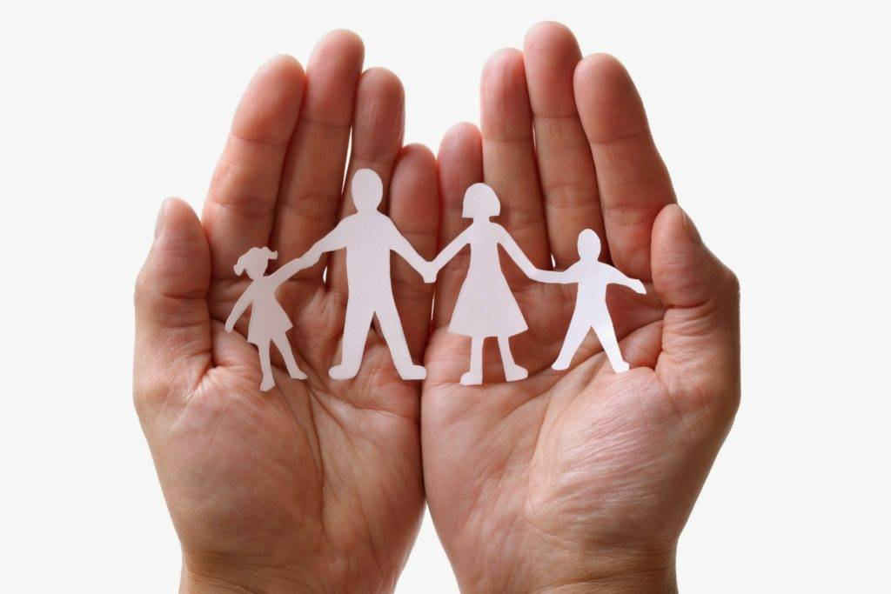

Safeguarding and Child Protection Policy

Written: 27/09/2021

Little Stars Childminding
Authored by: Joshua Morgan (DDS&IL)

Little Stars Childminding is fully committed to safeguarding the welfare of all children in its care. We recognize the responsibility to promote safe practice and to protect the children from harm, abuse, and exploitation. For the purpose of this policy and associated procedures; a child is recognized as someone under the age of 18 Years Old.
Staff and volunteers will work together to embrace difference and diversity and respect the rights of children and young people.

These guidelines are based on the following principles:
- The welfare of children is the primary concern
- All children, whatever their age, culture, disability, gender, language, racial origin, socio-economic status, religious belief and/or sexual identity have the right to protection from all forms of abuse or harm.
- Child protection is everyone’s responsibility
- Children have the right to express views on all matters which affect them, should they wish to do so.
- We will work in partnership with organizations together with children and parents/carers to promote the welfare, health, and development of children.
Little Stars Childminding will: -
- Promote the health and welfare of children by providing opportunities for them to take part in activities safely.
- Respect and promote the rights, wishes and feelings of children
- Promote and implement appropriate procedures to safeguard the well-being of children and protect them from abuse.
- Recruit, train, support and supervise our staff members and volunteers to adopt the best practice of safeguarding and protect the children from abuse and to reduce the risk to themselves.
- Require staff and volunteers to adopt and abide by this Safeguarding and Child Protection Policy.
- Respond to any allegations of misconduct or abuse of children in line with this Policy as well as implementing, where appropriate, the relevant disciplinary and appeals procedures.
- Observe guidelines issued by the Local Authority for the protection of children
- Regularly monitor and evaluate the implementation of this policy and these procedures.

Definition of Abuse:
There are many different types of abuse, children can be abused by an adult’s direct actions (e.g., beating a child) or because of an adult’s inaction (e.g., not feeding or bathing a child), and even an adult’s indirect action (e.g., domestic abuse, etc.).
Children can be abused by adults as well as by other young people or children.

The authorities will be notified if any professional suspects that a child is either suffering or at risk of suffering significant harm.

Sometimes a single traumatic event constitutes ‘significant harm’ to a child; and, sometimes, a build-up of concerns or a series of incidents over time also gives rise to ‘significant harm’.
The law recognizes the following categories of abuse under the Children Act (1998):

Physical:
• Where adults physically hurt or injure a child by hitting, shaking, squeezing, burning, biting, etc.
• Giving children alcohol, inappropriate drugs or poison is also considered physical abuse.

Sexual:
• Where adults use children to meet their own sexual needs
• This might be full intercourse, masturbation, oral sex, anal intercourse, or fondling.
• Showing children pornography and using sexualized language with children is also sexual abuse.

Emotional Abuse:
• When there is a persistent lack of love and affection that damage children emotionally.
• Being constantly shouted at, threatened, or taunted can make a child very nervous or/and withdrawn.
• Seeing or hearing another person being harmed also constitutes emotional abuse, as in Domestic Violence and parental Substance Misuse.

Neglect:
• Where adults fail to meet a child’s basic needs, for example for clothing or food.
• Children might also be left unsupervised and alone
• Sometimes adults fail or refuser to give children their love and affection.

Female Genital Mutilation (FGM) –

Female Genital Mutilation (FGM) is illegal in England and Wales under the FGM Act 2003 (“the 2003 Act”). It is a form of child abuse and violence against women. FGM comprises all procedures
involving partial or total removal of the external female genitalia for non-medical reasons.

We endeavor to adhere to the following:

- The safety and welfare of the child is paramount
- All agencies involved act in the interest of the rights of the child as stated in the UN convention 1989 and the Children’s act 1989.
- All professionals are made aware of the possibility of a girl being at risk of FGM as a result of religious beliefs, nationality and other unusual events that could led to FGM e.g., a child being taken out of the setting for six weeks or more by parents or relatives.

Types of FGM –

Female genital mutilation is classified into 4 major types.

- Type 1: (Clitoridectomy) – removing part or all of the clitoris.
- Type 2: (Excision) – removing part or all of the clitoris and the inner labia (lips that surround the vagina) with or without removal of the labia majora (larger outer lips).
- Type 3: (Infibulation) – narrowing of the vaginal opening by creating a seal, formed by
cutting and repositioning the labia.
- Other harmful procedures to the female genitals, including pricking, piercing, cutting, scraping, or burning to the area.

Effects of FGM –

There are no health benefits to FGM, and it can cause serious harm including:

- Constant pain
- Repeated infections, which can lead to infertility
- Bleeding, cysts, and abscesses
- Problems passing urine or incontinence
- Depression, flashbacks, and self-harm

FGM and mental health –

FGM can be extremely traumatic experience that can cause emotional difficulties
throughout life, including:

- Depression
- Anxiety
- Flashbacks to the time of the cutting
- Nightmares and other sleep problems

In some cases, women may not remember having FGM at all, especially if it was performed when
they were an infant.

Why FGM is carried out?

FGM is carried out for various cultural, religious, and social reasons within families and communities in the mistaken belief that it will benefit the girl in some way (for example, as a preparation for marriage or to preserve her virginity).
However, there are no acceptable reasons that justify FGM. It’s a harmful practice that isn’t required by any religion and there are no religious texts that say it should be done. There are no health benefits of FGM.
FGM usually happens to girls whose mothers, grandmothers or extended female family members
have had FGM themselves or if their father comes in from a community where it’s carried out.

Procedure for Abuse Against a Childminder -
As a Childminder Service, we are vulnerable to allegations of abuse being made against us or our families.
We will take precautions to protect ourselves from this happening by:
- Ensuring all household members over 16 are CRB/DBS cleared
- Ensuring all visitors to the house sign the visitors book and do not have unsupervised access
to the children under any circumstances
- Ensuring, where possible, that no workmen are in the house during minded hours, unless it
is to repair an emergency service or for Health and Safety Reasons.
- Document every accident and incident that occurs whilst in my care, informing parents and
requesting them to sign my records
- Noting any marks on the children when they arrive and asking parents to inform me of any
accidents that have occurred whilst outside my care
- Ensuring the children are supervised at all times
- Keeping accurate records on each child and writing a daily diary

However sometimes allegations are made, and this unfortunate situation cannot be avoided. We will then follow the procedure detailed below, in order to gain support and professional advice:

Contact: Local Authority Designated officer (LADO)
We will write a detailed report of all related incidents, including what was said and by whom, with
times and dates.
We will ask any witnesses (if there were any) to also write a statement detailing the incident they
witnessed and giving their contact details in case it needs to be followed up by the authorities.
We will contact Ofsted within 14 days of any allegation

Responsibilities and Expectations -
The Designated Safeguarding Lead (DSL) is Alice McPherson. The DSL is mostly available and if not then please contact our Deputy Designated Safeguarding & Inclusion Lead who will deal with any safeguarding concerns. Our Deputy Designated Safeguarding and Inclusion Lead (DDS&IL) is Joshua Morgan.

It is the responsibility of the DSL and DDS&IL to ensure that all safeguarding issues are effectively responded to, recorded, and referred to the appropriate agency. They are also responsible for arranging the whole settings safeguarding training for all staff and volunteers who work with the children. These training courses will take place at least every year, which they can be deliver within the setting provided they are linked into the support and quality assurance process offered by the local authority.

The DSL and DDS&IL is required to attend and assure that a senior member of staff who has the relevant training and access to appropriate supervision, attends where appropriate, all child protection case conferences, reviews, core groups or meetings where it concerns a child at our setting and top contribute to multi-agency discussions to safeguarding and promote the child’s welfare to the best of our ability.

The DSL and DDS&IL is responsible for ensuring the acceptable, safe use and storage of all camera technology, images, and mobile phones through the implementation, monitoring and reviewing the appropriate policies and procedures. This includes the E-Safety Policy.

All child protection concerns need to be acted on immediately. If you are concerned that a child may be at risk or is actually suffering abuse, you must tell the DSL or DDS&IL if the DSL cannot be contacted.

The Prevent Duty -
In Line with section 26 of the counterterrorism and security act (2015) we understand the importance of staff members being able to recognise and identify vulnerable children and to have “due regard to the need to prevent people from being drawn into terrorism”.

We recognise the importance of protecting children from the risk of radicalisation and promoting British Values in the same way we would protect and safeguard children from any other abuse.

We will ensure all staff members are able to notice changes in children’s behaviour as we would do with any kind of safeguarding matter as there is no single way of being able to identify a child who is at risk of being vulnerable or susceptible to radicalisation/extremism.

All staff members are also aware of the appropriate time to make a referral to the “channel programme”.

Making A Report –
Child abuse can be physical, sexual, emotional, neglect, domestic, or a mixture of these. We have regular training on how to spot the signs of abuse and have a duty to refer any concern to the Local Authority.
We must notify Ofsted of any allegations of abuse that are alleged to have happened in the setting.

Parents, Carers and Guardians must notify the Safeguarding Team or the child’s Key Person of any concerns they have about their child, and any accidents, incidents or injuries affecting the child, which we will record and ask parents to sign. Unless we believe that it would put the child at risk of further harm. We will discuss concerns with a child’s parent if the following are met:

- Significant changes in behaviour
- Deterioration in child’s general well-being
- Unexplained bruises, marks or signs of possible abuse or neglect
- Children’s and parent’s comments which give cause for concern, including expressing extremist views
- Any reasons to suspect neglect or abuse outside the setting, for example in the child’s home
- Inappropriate behaviour displayed by other staff members, and any person working with children.

Where a child fails to attend unexpectedly, we will take all necessary action to attempt contact with their parents. If contact cannot be made after one hour, we will attempt to contact via other means. Either a house visits or email home.
Any unexpected absence will be reported to the police and/or The Local Authority via the correct channels, if we cannot contact you after all attempts have been made.

If a child tells us that they are experiencing, or another child is experiencing abuse; we will:
- Show that we have listened to what they have said and take the allegation seriously.
- Encourage the child to talk but will not prompt them or ask questions that are leading. We will not interrupt when a child is recalling significant events and will not make a child repeat themselves.
- Explain the actions we must take, in a way that is appropriate for their age and understanding of the child.
- Record what has been said, word for word to the best of the staff’s ability, and make a note of time, date and people present, including the child.
- Refer the concern to the Safeguarding Team: DSL and Deputy DSL

The Safeguarding Team will contact the Local Authority with the concern details and gain advice from the appropriate services.

In all instances of making a referral to Local Authority, we will provide personal details about the relevant child such as full name, date of birth, address and other personal information that is requested via Local Authority to assist in their enquiry.

All referrals and documents regarding the concern will be kept via hard copy in a secure folder which we will keep until the child leaves the setting.

Mental Health and Emotional Wellbeing –
At Little Stars Childminding, we are committed to supporting the emotional health and wellbeing of all children and staff who attend our setting.

Little Stars Childminding knows that everyone experiences life challenges that can make us vulnerable and at times, anyone may need additional support. We take the view that positive mental health and emotional wellbeing is everybody’s business and that we all have a role to play to uphold positive mental health.

Little Stars Childminding will:
- Help children to understand their emotions and feelings better
- Help children feel comfortable sharing any concerns or worries
- Help children socially to form and maintain relationships
- Promote self-esteem and ensure children to be confident and ‘dare to be different’
- Help children to develop emotional resilience and to manage setbacks
We pursue our aims through:
- Universal approach to all children
- Support children going through recent difficulties, including bereavement
- Specialized, targeted approaches for children with more complex or long-term difficulties

Targeted Approach –

Little Stars Childminding will offer support through targeted approach for individual children or groups of children which may include:
- Team or group activities
- Targeted use of resources
- Managing feelings resources
- Managing emotions resources
- Mental Health Services and Information
- Therapeutic activities like art, Lego, relaxation and child Yoga

Little Stars Childminding will make use of these resources to assess and track wellbeing appropriately including:
- Strength and Difficulties assessments
- Emotional Literacy Scales
- Emotional Provocation Scales
- Overall Assessments

Signposting –
Little Stars Childminding will ensure staff, children and parents are aware what services are available within our setting and how to access further support if needed.

Identifying needs and warning –
All staff involved with children will complete wellbeing assessments throughout their observations aimed to identify a range of possible difficulties including:
- Attendance
- Relationships
- Approach to learning/Play
- Physical Indicators
- Negative Behaviour Patterns
- Family Circumstances
- Recent Bereavement
- Health Indicators

Domestic Violence
Seeing, hearing or knowing of a parent being abused is traumatic for children and can have long-term damaging emotional and psychological effects. Wherever Domestic Violence is suspected in a home where a child is resident, we have a duty of care to the child to which we need to refer this to the Local Authority, who have a duty to investigate.

Supporting Children -
We recognise that a child who is abused or witnesses’ violence may find it difficult to develop and maintain a sense of self-worth. We recognise that a child in these circumstances may feel helpless and humiliated and may feel self-blame.
We recognise that the setting may provide the only stability in the life of a child who is being abused or is at risk from harm
We accept the behaviour of a child in these circumstances may range from that which is perceived to be normal and may be particularly aggressive or withdrawn
We will support children and their families by:
- Encouraging self-esteem and self-assertiveness whilst not condoning aggression or bullying
- Promoting a caring, safe and positive environment within the setting
- Liaising and working together with all other support services and those agencies involved in the safeguarding of children
- Providing continuing and planned support for a child about whom there are concerns

Safeguarding Concern Review Conference (SCRC) –
Every term we hold two review conferences to make sure we are taking the appropriate actions in all safeguarding and child protection cases. We will always strive to make sure that our policy and procedures are adhered to. This means reviewing our current activity but also taking a look back at what we have done and what we should do to improve our Safeguarding and Child Protection procedures.

During our SCRC we will look at attendance, development, open and closed concerns and our approach to them. We look at attendance to find irregularities in attendance and to follow them up so we can keep our attendance records up to date.
We look at development to find where children maybe falling behind but also progressing at a good level.
We will also look at open and closed concern cases to make sure we are and have followed the correct procedure, and to make sure these concerns are the same or need to be re-reported to the Local Authority.

A template of the SCRC Report can be located on the website.

Note: If a urgent concern is raised, a review will be held on how to best deal with the situation within 48 hours of the urgent concern being raised. Please refer to “Making a Report” in this policy about our procedure on reporting concerns.

Contact Information –

Designated Safeguarding Lead  (DSL) | Alice Mcpherson | Safeguardingteam.littlestars@gmail.com  +44 7359 132122
Deputy Designated Safeguarding and Inclusion Lead  (DDSIL) | Joshua Morgan | Safeguardingteam.littlestars@gmail.com  +44 7359 132122
Special Educational Needs Co-Ordinator  (SENCo) | Alice Mcpherson | Safeguardingteam.littlestars@gmail.com  +44 7359 132122
General Enquires about Little Stars Childminding | Alice Mcpherson & Kellie Grey | Littlestars_childminding@hotmail.com  +44 7359 132122
Local Authority Designated Officer  (LADO) | Kent County Council | kentchildrenslado@kent.gov.uk  03000 41 08 88
Children’s Social Services | Kent County Council | social.services@kent.gov.uk  03000 41 11 11  Out of Hours: 03000 41 91 91
Kent Police | Kent Police | Non-emergency – 101  Emergency - 999

Monitoring -
This policy will be reviewed a year after development and then every two years, or in the following circumstances:
- Changes in legislation and/or government guidance
- As required by the Local Authority
- As a result of any other significant change or event

Policy Review Date: 27th September 2022
Last Review: 27th September 2021

