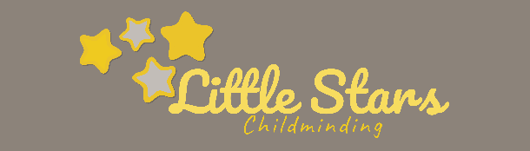
Animals and Pet Policy
Written by: Alice Mcpherson Date: 16.07.2021

I own the following pets: Medium sized – Dog

As the owner of pets, I have written this policy to share information about how I protect child/ren from harm when there are pets in the house.

Children learn from handling and coming into contact with pets, and I will ensure they have a sustained learning experience by planning activities to help the children get to know the pets and how to manage them safely.

Children will have contact with the pets on a day-to-day basis and will be taught to treat the pets with respect. They will learn how to handle the pets safely under careful and constant supervision.

Children will be taught to wash their hands thoroughly after handling pets.

Food for the pets is stored out of sight and reach of the children and children will not be allowed to access the pets when they are eating.

Constant risk assessment will ensure children are safe in the house and garden: for example, I risk assess through the day to ensure pets have not soiled parts of the garden where children play.

Meeting other animals - children are taught that not all animals are friendly. My rule is that they need to be with an adult and to ask before touching animals if they do not know their name.

Outings to see animals - I sometimes take children on outings to meet animals – for example, to watch feeding time at the petting zoo or on a farm visit. I take every precaution to keep children safe – please ask if you would like to discuss my outing risk assessment.

If you have any questions about my Policy / Procedures or would like to make any comments, please ask.

Signed: Review date:
