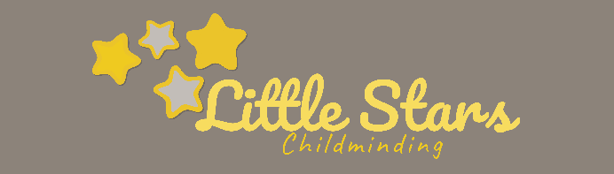
Healthy Eating Policy

Written by: Alice Mcpherson Date: 16.07.2021

I take pride in my healthy food and drink provision.

EYFS requirement 3.45 – Where children are provided with meals, snacks, and drinks, they must be healthy, balanced, and nutritious.

I am committed to offering children healthy, nutritious food which meets their individual dietary requirements as advised by their parents. All food is freshly prepared, using best quality ingredients where possible and presented well. Portion sizes are realistic, and children are never asked to clear plates as I am aware of the risks of over-eating.

Teaching children - I teach children about healthy eating and drinking as part of our daily routine. Children help to buy, prepare and cook food and enjoy helping in the kitchen. Risk assessments help to keep children safe in the kitchen and when they are cooking.

Special food - food is often used as part of a festival, birthday or celebration and I sometimes offer children food which might not be considered healthy such as cakes for a birthday party. If parents have a concern about this they should let me know.

EYFS requirement 3.45 – Fresh drinking water must be always available and accessible.

Fresh drinking water is provided in age-appropriate cups on a tray which is accessible for all the children; outside water is provided in a ‘help yourself’ dispenser and the children use open cups or sports bottles depending on preference.

EYFS requirement 3.45 – Before a child is admitted to the setting the provider must also obtain information about any special dietary requirements, preferences, and food allergies that the child has, and any special health requirement. Providers must record and act on information from parents and careers about a child's dietary needs.

As part of induction, I ask parents about their child’s dietary needs. I consider likes, dislikes, allergies, intolerances, religious and cultural needs when planning menus – see Menu Planner for more information. I keep this information regularly updated. If I am told that children need food at times other than my usual mealtimes or different from my usual menu items to accommodate medical needs, I will make arrangements to support them.

EYFS requirement 3.47 – Registered providers must notify Ofsted of any food poisoning affecting two or more children looked after on the premises. Notification must be made as soon as is reasonably practicable, but in any event within 14 days of the incident. A registered provider, who, without reasonable excuse, fails to comply with this requirement, commits an offence.

I am aware of the requirements under the Public Health (Infection Diseases) Regulations 1988 regarding food poisoning and the requirement to inform Ofsted, acting on advice given by the Health Protection Agency. If I must make a report an Incident Record will be completed.

EYFS requirement 3.48 - There must be an area which is adequately equipped to provide healthy meals, snacks, and drinks for children as necessary. There must be suitable facilities for the hygienic preparation of food for children, if necessary, including suitable sterilisation equipment for babies’ food. Providers must be confident that those responsible for preparing and handling food are competent to do so. In group provision, all staff involved in preparing and handling food must receive training in food hygiene.
I am registered with the Local Authority Environmental Health Department as a food provider. I use the guidance ‘Safer Food Better Business for Childminders’ from the Food Standards Agency. I am aware of the requirement to report food poisoning affecting two or more children cared for on the premises. Baby equipment can be sterilised using hot or cold-water techniques.

Updated for coronavirus – 04.2020
Extra precautions, guided by Public Health England, will be taken to keep children as safe as possible and practical when preparing food, eating, or drinking in the setting. For example, the following risk assessments will be carried out –
- Children’s drinking cups will be personalized to ensure they are not shared
- When children are making food, they will have their own specified area in which to work
- Hand washing routines will be updated and shared with parents – if soap and water are not available, hand gel and wipes will be used.
- Children will be reminded not to share food or drink
- Hand contact points will be regularly cleaned and sterilized.

If you have any questions about my Policy / Procedures or would like to make any comments, please ask.

Signed: Review date:

